|  |
| --- |
|  |
| Integrated Project |
|  |

|  |
| --- |
|  |

Vasiliki Tsirogianni- BSc Computing - S1825013

Jack Weir – BSc Computing – S1830098

Federico Vivaldo- BSc Computing – S1828951

Darren Smith- BSc Software Development for Business- S1821377

Contents

**Introduction3**

* Functional requirements3
* Non-functional requirements4-5
* Issues and assumptions5

**Business Case6**

* Reasons for the project6
* Business options6
* Expected benefits6
* Expected dis-benefits7
* Timescale7
* Costs7
* Major risks7

**Use case diagrams8**

* User registration9
* Log in9
* Book an appointment10
* View timetable10
* Update status11
* Services available11
* Update details12
* Cancel account12
* Class diagrams13

**Prototype screen layouts14**

* Home page14
* Register14
* Log in15
* My account15
* Book appointment16
* My timetable16
* Services17
* Update personal information17
* Update patient’s status18

**The implemented system19**

* How the system was developed19
* The final system20-25
* Test plan26-28
* Evaluation of the system29

**Group meeting notes30-37**

**References38**

**Introduction**

Our team is a group of four students consisted of two departments of study, BSc Computing and BSc Software Development for Business. The members are: Vicky Tsirogianni (BSc Computing), Federico Vivaldo (BSc Computing), Darren Smith (BSc Software Development for Business) and Jack Weir (BSc Computing). We tried not just to divide our work by assigning different tasks to each one of the team’s members, but to discuss, analyze and improve every aspect of the proposed system together.

Using an agile development process and a series of increments the team will analyze the proposed system’s needs, planning, implementing and improving every new piece of the software. The purpose of the system is to help the Sports and Wellbeing clinic to manage patients’ personal data, therapists’ schedules, treatments’ timetables effectively and efficiently.

The system will have a variety of users, people that will work for the clinic, staff and students from the University, as well as members of the public. User groups could be divided as follows:

* Patients (staff and students from the University, members of the public)
* Therapists (coaches, nurses, doctors, staff of the clinic)
* IT
* Director of the clinic
* Administration

To ensure that the expected services requested by the user are met, some of the following features must be implemented:

**Functional Requirements**

* Patients and staff will have their own personal account to make their appointments and manage their treatments. They will need to provide their name, surname, telephone number and username, (in the case of a therapist a unique ID number, provided by the clinic, must be used instead of a username.)
* The system will allow the users to have access to their personal files, to update, manage or delete their personal information and account whenever they desire. (The users could not change the username and ID number.)
* The system will allow the users to search for all the available services and treatments, timetables and appointments, providing all the important details for simple and fast booking.
* The system will allow the users to book more than one appointment at the same time.
* The system will allow the users (therapists) to change the status(progress) of the appointment.

**Non-functional requirements**

* **Availability**

The system will be available online 24 hours a day, 7 days a week. This is to mitigate the restrictions of running a call center during office hours. The system must have no more than 30 minutes of down time in any 24-hour period. New deployment of the system or issues such as power outages must not impact the main page of the online booking system. If any other page of the system experiences a problem, a notification must be displayed informing the customer about the issue and the time it will need to be up again.

* **Accessibility**

The booking system will be accessible anywhere through the browser or the application on pc’s, laptops, tablets and smart phones. The website must be lightweight to work across a large range of devices. The system must work for any hardware, software, location or ability. The application download should not take more than 15 seconds on a stable connection.

* **Usability**

The system should be designed for a wide range of users, from different age categories and with different abilities, hence, the instructions and the steps that the customer must follow must be clear. All the main options like register, sign in and services must use bolder and larger fonts than the other options and must lead them directly to the page that it’s heading implies. The users should access to every head page with no more than 3 clicks.

* **Reliability**

The system should preserve data contents especially when failures occurs. If the system is overcrowded or hard drive stops working, or malicious software damages the system etc. an incremental backup should be running making copies of the new files or any other files that have been changed the last 24 hours.

* **Performance**

The front-page load of the booking system must be no more than 2 seconds when the users accesses either from the website or from the application. The system will be able to be used by multiple users at one time. The system must be able to handle 100 bookings at one time to ensure that people don’t get locked out and turned away. The system will delete accounts after 1 year of inactivity. This is to keep the database smaller and running efficiently.

* **Updatability**

The system must have a way to be updated in real time across the board. When costs, offers, schedules or pictures are changed an update will be made across the whole site to ensure that users don’t get misled before all areas have been updated. Changes should be available and updated to client within 5 seconds of employee committing it on the system.

* **Secure**

The system must feature end to end encryption throughout the booking process to ensure that all user’s details are kept safe from being hacked. Users must register with the system before being able to purchase, the registration process will have a captcha check to make sure the user is real. Passwords must be complex, they must have at least 6 characters, a capital letter, a symbol and a number, to lower the risk of accounts being compromised. The system will prompt the user to change the password every 6 months to minimize the risk of personal data leakage.

* **Maintainability/Scalability**

In order to maintain, develop, grow and modify the system, correcting any faults and improving its services, the system should be eligible to changes and new implementations. If any errors come to the surface, then this part of the system will be deployed, tested and integrated in a 2-week period.

* **Recoverability**

To protect, secure and recover the system from a data loss, all the backup files that are created every 24 hours, will be uploaded and saved at cloud. The backup will be created during off-peak hours at 4AM.

**Issues and assumptions**

During research some issues came to the surface and the following assumptions were made for the proposed system:

* To simplify the complexity of the system, all the services will have a cost of 10 pounds per session.
* Patients will have to pay for their treatment when they arrive at the clinic with cash or card.
* The users will be divided in two categories, patients and therapists. The patients will have to give a username when they register and the therapists a unique ID number. (this will be provided by the clinic)
* The system will display only 3 available services.
* The patients will not have the ability to cancel or change an appointment from the proposed system.
* The final system will work online.

**Business Case**

**Reasons for the project**

The Sports and Wellbeing clinic has been struggling with the amount of data that has to handle, like updating patients records, booking appointments manually or controlling therapists’ schedules and timetables. All these issues have resulted in a drop-in clinic’s revenues, a lot of complaints and extremely high pressure to the reception who is trying to organize everything.

**Business Options**

* **Do nothing:** If the clinic decides to do nothing about these problems it could result in continuing dropping of the business’s revenues and potentially in closure.
* **Using a simple appointment system:** Using a simple appointment system that will provide the functionality of a calendar, will cost less than creating a total new software, without the need of waiting 3 months until the system is completely prepared. With this option, most of the work will be done manually like: checking the availability for new appointments. Although this scenario may seem easier and faster, it is unlikely to provide the help and the coveted increase of revenue.
* **Developing a new online system:** Building a new system for the clinic, implementing all the features that are necessary to the business, developing a software that will be adaptable to the changes that may come and minimizing the risk of losing important data or appointments, will provide a high and personalized customer service quality.

The new system will give flexibility not only to the staff but also to the patients. The staff will have the ability to check their schedule and all the changes that may come like: cancelations, without concerning for updates. The clients will be able to check their progress, their schedule, new treatments, costs and so on and all the files and data will be protected and secure at cloud.

**Expected benefits**

Using an agile development process will give the flexibility to work with the clients, highlighting the features that need to be implemented first and customizing those ones that need to be improved. It is expected that within the first 3 months, the system will help the business by increasing its revenue by 10%. Within the first 2 months, the clinic will be able to use only the online booking system, transferring all the data that were written in simple excel, word, handwritten etc. documents and leaving behind the old confusing and complicated system. The proposed system will also help the staff and especially the reception to diminish the pressure and the work that needs to be done, as most of the work will be automated.

**Expected dis-benefits**

The only dis-benefit that this process will cause is a small disruption to the staff, as they will need at least two weeks to feel comfortable with the system and its functionality.

**Timescale**

The project will be delivered in 12 weeks (not the online system). After the first 4 weeks, the first implementation of the system will be released, and the clinic will be able to use the simple version of the software. The system will provide a time table, so they can book the appointments manually, the ability to create patients’ files and to display all the services. After 4 weeks the second increment will be released, and the final online version will be on week 12. During this period the staff will have the opportunity to test the system and give a feedback to our team, so we can improve the features that may not work as they supposed to. If any issues arise, the system will release another version in a moth. The benefits will start appearing during the first 2 months and the complete usability of the system will be obvious after the first 6 months.

**Costs**

The cost will be 10,000 plus or minus 3,000 and for every new implementation that the business may need the cost will be calculated based on time and the effort that we may need which will be discussed between the clinic’s manager and the development team.

* 40% of the total amount will be used for Design
* 25% for Test
* 20% for Analysis
* And 15% for Implementation

**Major risks**

Every new project that is created presents some risks. Will the system be delivered on time? Will the funds that the company invest on the proposed system meet their expectations? Will the system be viable? Has the development team managed all the potential safety issues like: what will happen if a therapist’s ID get lost and someone gets access to the system?

Even though these issues seem crucial for the smooth operation of the clinic, they can easily be solved with the proper preparation and tests. The most important risk that may appear is the disruption of the workers’ schedule until they accept and understand the functionality and the necessity of the system.

**Use Case diagrams**



Patient

Therapist



User Registration

Log in

Book an appointment

View Timetable

Update Status

Services Available

Update Details

Cancel Account

|  |  |
| --- | --- |
| **Use Case Name** | User Registration |
| **Actors** | Users (both patients and therapists) |
| **Brief Description** | The scope of this use case is to allow the user to complete a full registration process. |
| **Pre-conditions** | The user must be connected to the system. |
| **Post-conditions** | Possibility to use his credentials to log in the system. |
| **Normal Flow of Events** | 1. The user is asked to navigate to the medical center webpage. 2. Once inside the registration process the user is asked to enter his personal details (name, surname and telephone number) as well as a username. If he is a therapist, is asked to enter a unique ID number instead of a username. The ID will be provided by the clinic. |
| **Alternative Flow of Events** | * If the user doesn’t provide all of the necessary information, a warning pop-up window will appear. |

|  |  |
| --- | --- |
| **Use Case Name** | Log in |
| **Actors** | Users (both patients and therapists) |
| **Brief Description** | This use case allows the user to access, navigate, manage the bookings and modify the details inside his personal section. |
| **Pre-conditions** | Must have registered. |
| **Post-conditions** | Can access the multiple functionalities of the proposed platform. |
| **Normal Flow of Events** | 1. Once the user navigates on the main webpage a button saying ‘Log-in’ allows the user to log in. 2. The user is then asked to log in by entering his username or therapist ID chosen during the registration process. 3. The final step is to click on the log in button which will take the user to the dashboard. |
| **Alternative Flow of Events** | * If a username or therapist ID doesn’t exist a warning window will appear. * If the user doesn’t exist a warning pop-up window will appear. |

|  |  |
| --- | --- |
| **Use Case Name** | Book an appointment |
| **Actors** | Users (Patients) |
| **Brief Description** | The user can book an appointment by choosing the service, the date and the length of the session. |
| **Pre-conditions** | User must have registered and logged in. |
| **Post-conditions** | The use- patient obtains a full confirmed booking for a specified day. |
| **Normal Flow of Events** | 1. Once logged in the user can select ‘Book Now’. 2. Under the ‘Book Now’ section the user can select their desired service using a drop-down menu. 3. The user then enters their desired length of service and the date of the service. 4. Once all the information is entered the user then clicks ‘book now’. |
| **Alternative Flow of Events** | * If the user does not enter any or incorrect information when booking, then they will be prevented from booking an appointment and a warning pop-up window will appear. |

|  |  |
| --- | --- |
| **Use Case Name** | View Timetable |
| **Actors** | Users (both patients and therapists) |
| **Brief Description** | Allows the patients and therapists to see past and upcoming appointments. |
| **Pre-conditions** | Must have registered, logged-in and already booked at least one appointment. |
| **Post-conditions** | Both users can see the progress. |
| **Normal Flow of Events** | 1. Once logged in the user is prompted in his proper dashboard where several options and functionalities are displayed 2. Once clicked on view timetable, not only a page with a list containing the treatments is shown, but also says if the various practices are completed or in pending. |
| **Alternative Flow of Events** | * If the user or the therapist has never had respectively a treatment or a patient, once clicked on view timetable, no appointments will appear. |

|  |  |
| --- | --- |
| **Use Case Name** | Update Status |
| **Actors** | Users (Therapists) |
| **Brief Description** | Update status of appointments from ‘pending’ to ‘complete’, ‘in progress’ or ‘not completed’. |
| **Pre-conditions** | Must have booked an appointment. |
| **Post-conditions** | The users can display the updated details. |
| **Normal Flow of Events** | 1. Once the therapist has logged in, he can click on update status and then be prompted to enter the new status, patient’s user name, date of appointment, and the service. 2. A text box will appear displaying the new status of the appointment. |
| **Alternative Flow of Events** | * If the user enters an incorrect patient username they will be unable to update the status. |

|  |  |
| --- | --- |
| **Use Case Name** | Services Available |
| **Actors** | Users (Patients) |
| **Brief Description** | Gives users a description of each available service. |
| **Pre-conditions** | Must have registered and logged in. |
| **Post-conditions** | The users can display the description of a desired service. |
| **Normal Flow of Events** | 1. User clicks ‘Services Available’ on dashboard page.  2. User is then given a drop-down menu of available services, allowing them to select one.  3. User selects desired service from drop down and clicks ‘get info’.  4. Description of service is displayed. |
| **Alternative Flow of Events** | If the user does not select a service and clicks get info, an error message will display. |

|  |  |
| --- | --- |
| **Use Case Name** | Update Details |
| **Actors** | Users (Patients) |
| **Brief Description** | Allows users to update their name and phone number. |
| **Pre-conditions** | Must have registered and logged in. |
| **Post-conditions** | The user’s credentials will be changed but username will remain the same. |
| **Normal Flow of Events** | 1.User clicks ‘Update Details’ on dashboard page.  2.User can then enter their new name, surname and phone number.  3. User clicks ‘Update’ and a message will appear confirming the new details. |
| **Alternative Flow of Events** | * User may not enter any details and click update. * A warning pop-up window will appear to prompt the user to add the details. |

|  |  |
| --- | --- |
| **Use Case Name** | Cancel Account |
| **Actors** | Users (Patients) |
| **Brief Description** | Allows users to delete their account. |
| **Pre-conditions** | Must have registered and logged in. |
| **Post-conditions** | The user’s account will not be active anymore. |
| **Normal Flow of Events** | 1.User clicks ‘Cancel Account’ on dashboard page.  2.A pop-up windows will appear, asking the user if he really wants to delete the account.  3.User clicks ‘Yes’.  4.A pop-up window will appear, informing the user that the account is deleted. |
| **Alternative Flow of Events** | * User clicks ‘No’ or ‘Cancel’. |

**Class Diagrams**

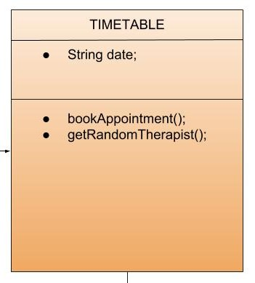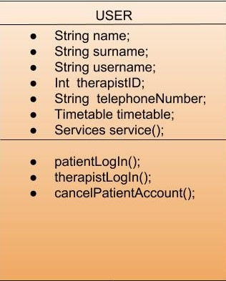

0…*

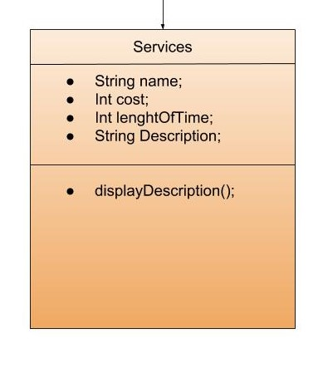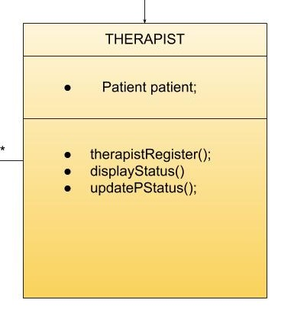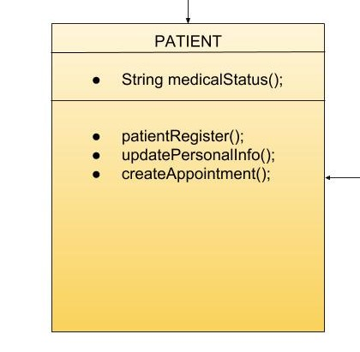

*…0

**Prototype Screen layouts**

**“Home Page”**

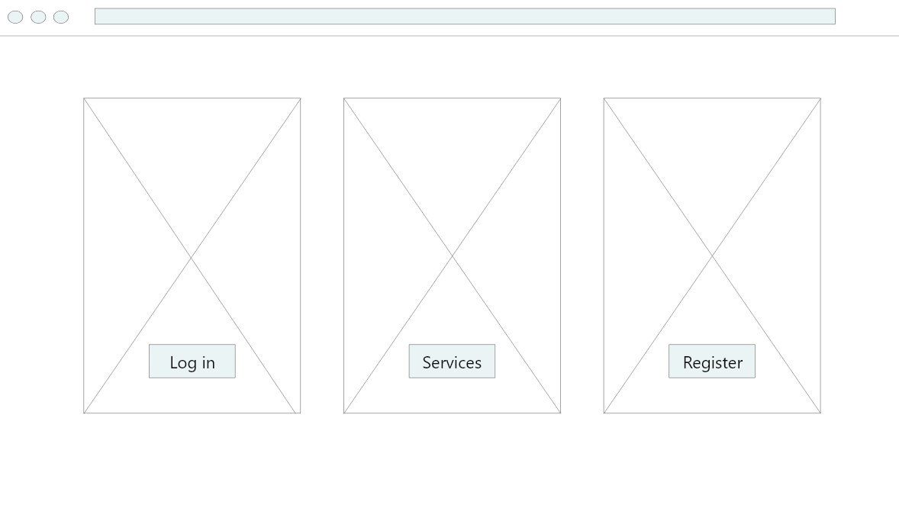

1.Wireframe/Home Page

**“Register”**

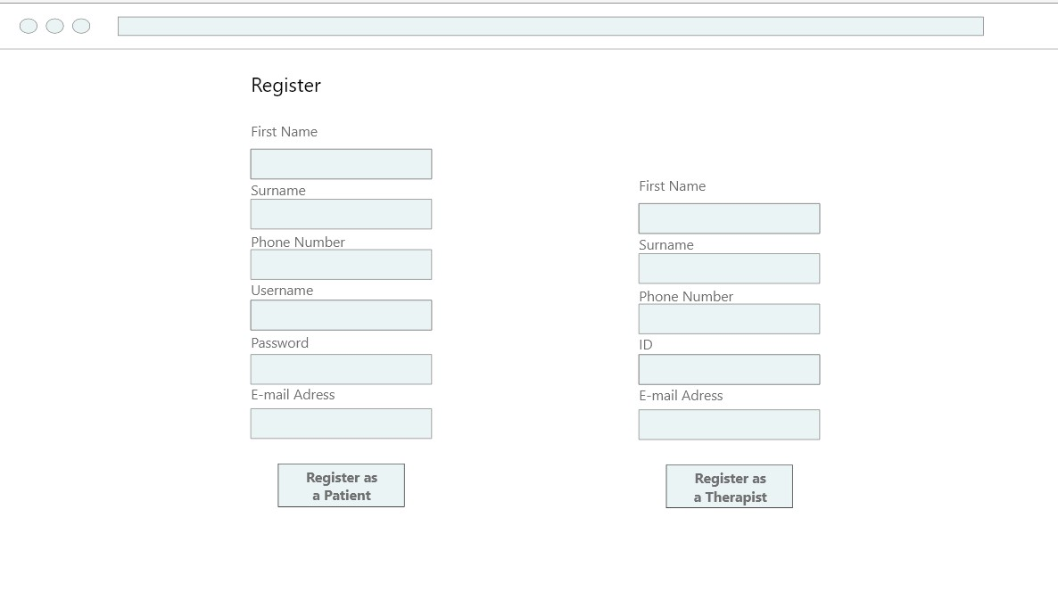

2.Wireframe/Register

**“Log in”**

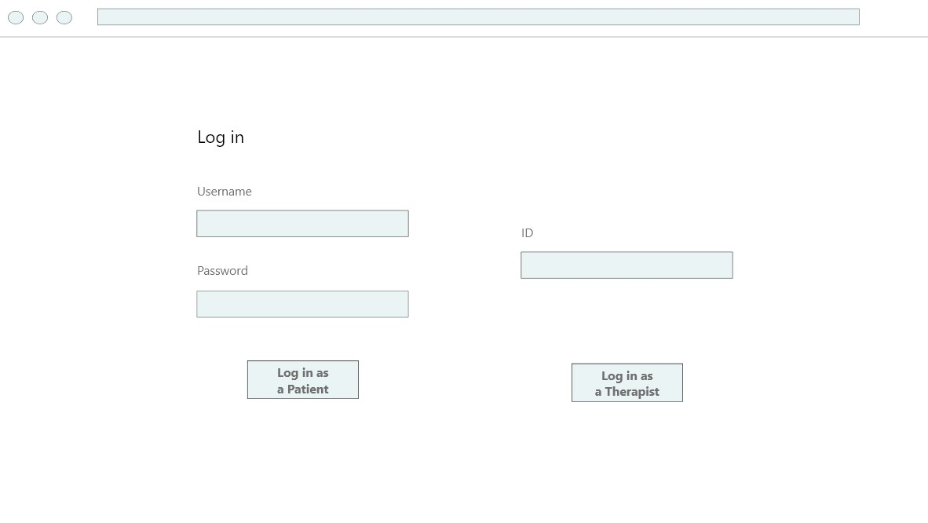

3.Wireframe/Log in

**“My Account”**

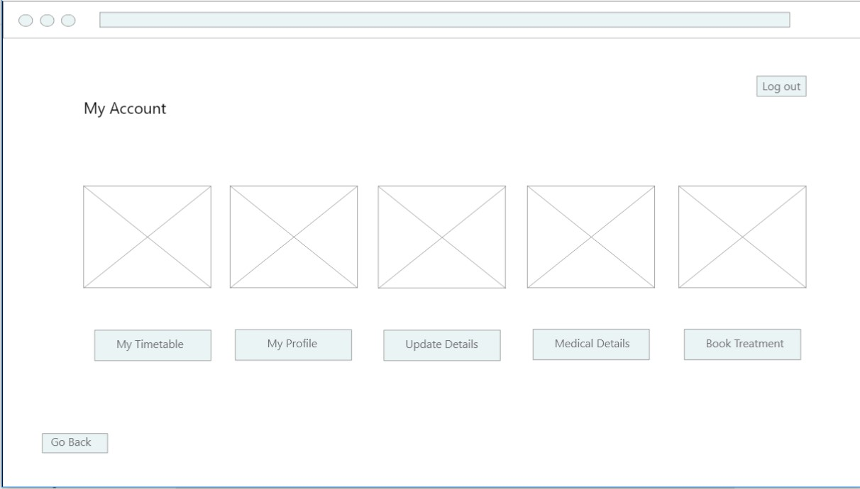

4.Wireframe/My Account

**“Book Appointment”**

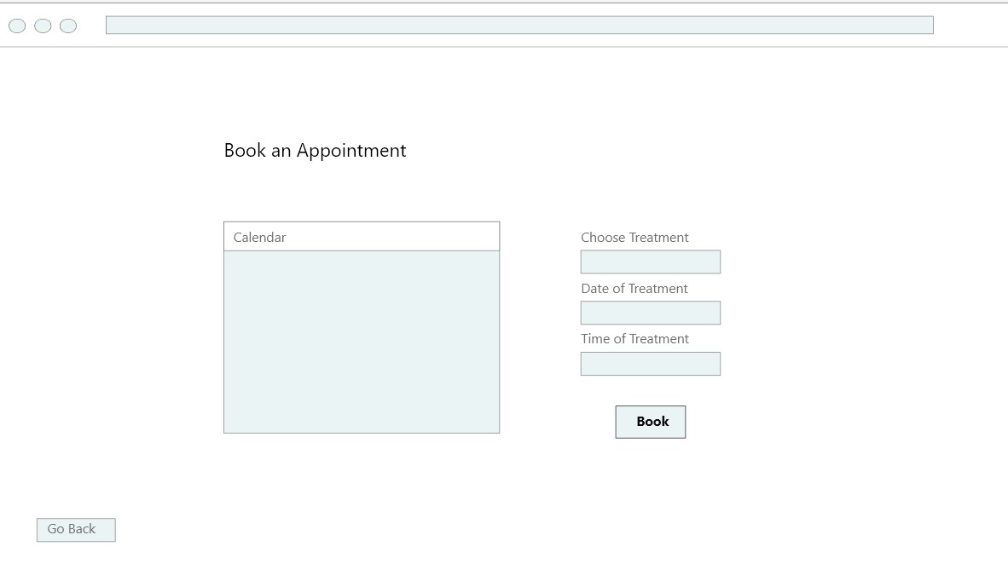

5.Wireframe/Book Appointment

**“My Timetable”**

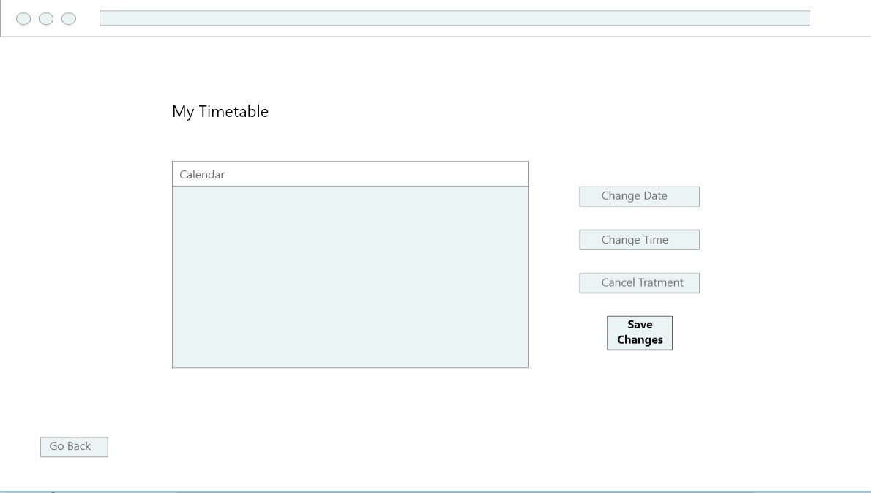

6.Wireframe/My Timetable

**“Services”**

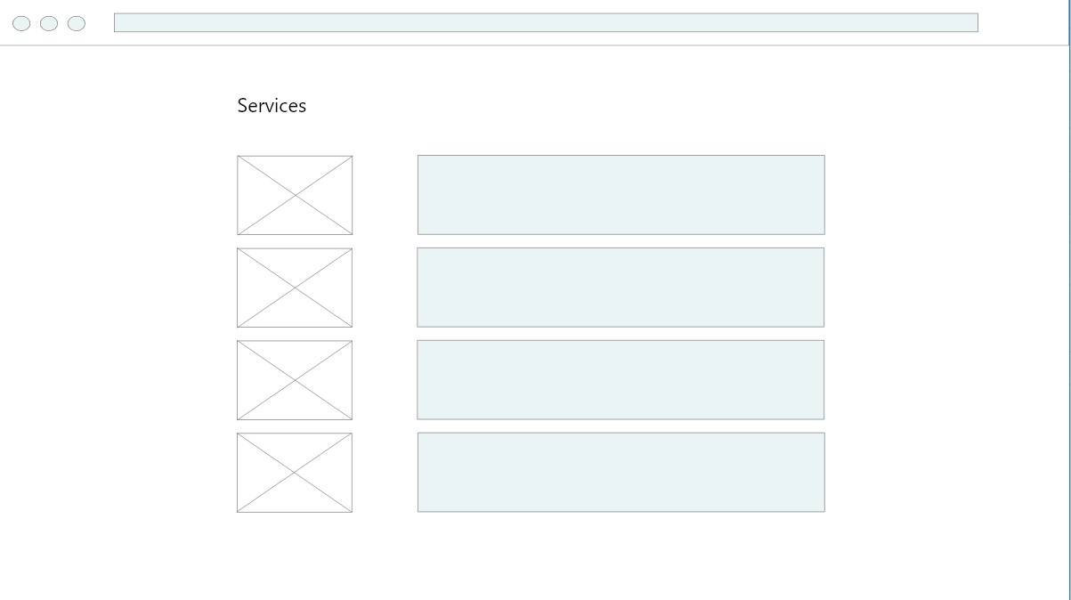

7.Wireframe/Services

**“Update Personal Information”**

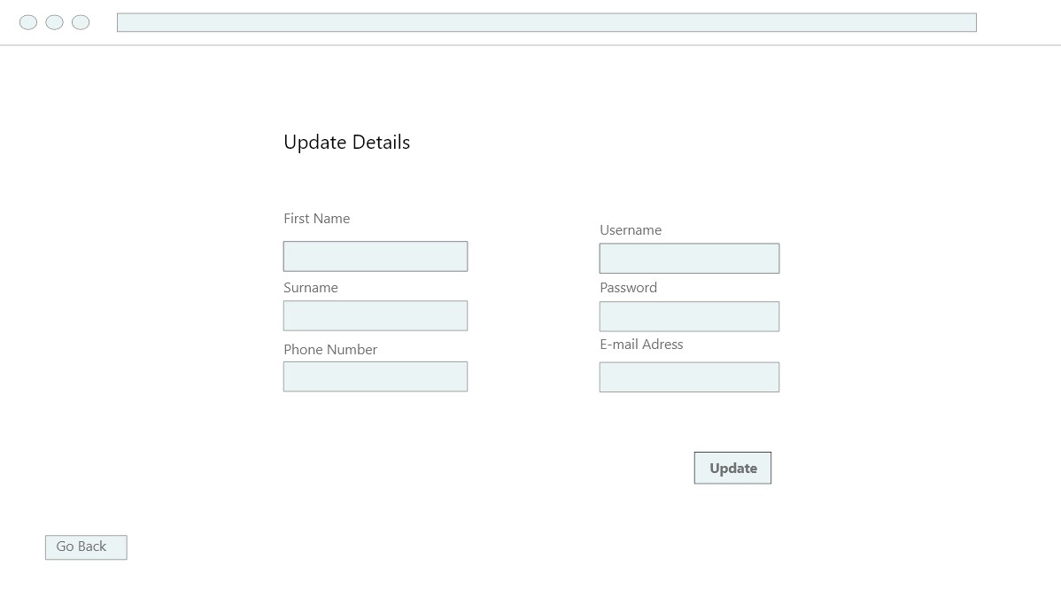

8.Wireframe/Update Personal Information

**“Update Patient’s Status”**

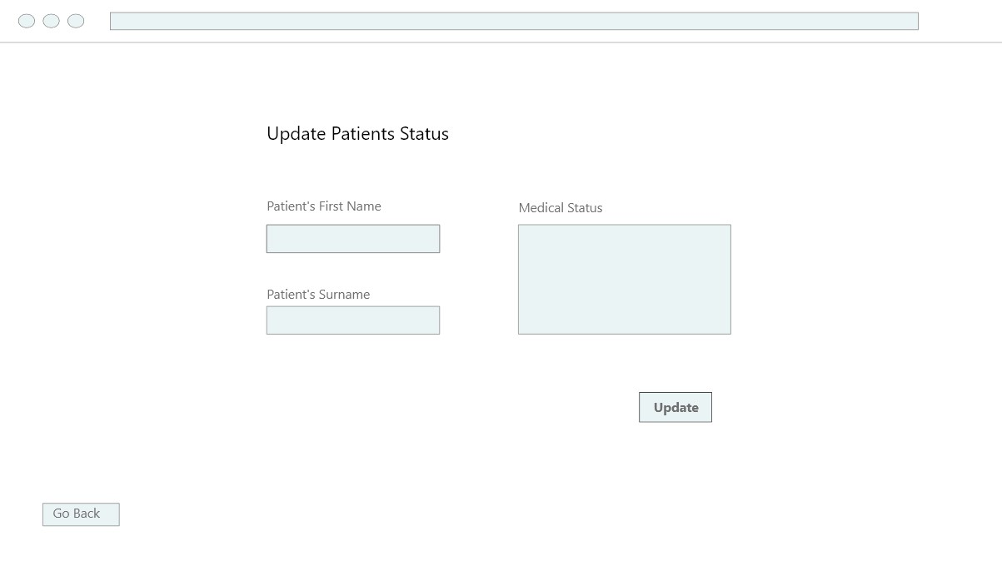

9.Wireframe/Update Patient’s Status

**The implemented system**

**How the system was developed**

The system was developed using an agile approach, creating the most important pieces of the program first, the class diagrams. In the beginning, the system was divided in 4 classes, the Users, the Services, the Timetable and the Calendar.

Inside the Users class were two different categories of people, the patients and the therapists. To establish that the system will recognize, authenticate and display all the necessary information to each user, two separate subclasses of the Users class had to be implemented (Patients and Therapists). The functionality of the two new classes were to create a new user after registration. The program had to display an option, so the user could register as a patient or as a therapist. After providing the necessary information like: name, surname, etc, the user could log in providing the personal username.

The Services class had only the names, the costs and the methods to display the description or the total cost for all the registered services of the clinic, and the two other classes had the methods to display a calendar and the weekly personal timetable.

After the completion of the basic methods and constructors, three text files had to be created, one for the patients’ personal information, one for the therapists’ and the last one for all the appointments that will be created from the Timetable class, so all the data could be saved and reused.

After running the program and the related tests, it became clear that there was no need to have four major classes but three, the Users, the Services and the Timetable. The Calendar class could only display a normal calendar at that time, and since all the details for the appointments would be written as Strings in the text files, there was no need to have access to a monthly regular calendar.

**The final system**

The user will first register as either a patient or as a therapist; through their name, surname and username for the patient: and a specific ID code for the therapist. Once registration is completed, the user will be able to login and have access to the clinics services.

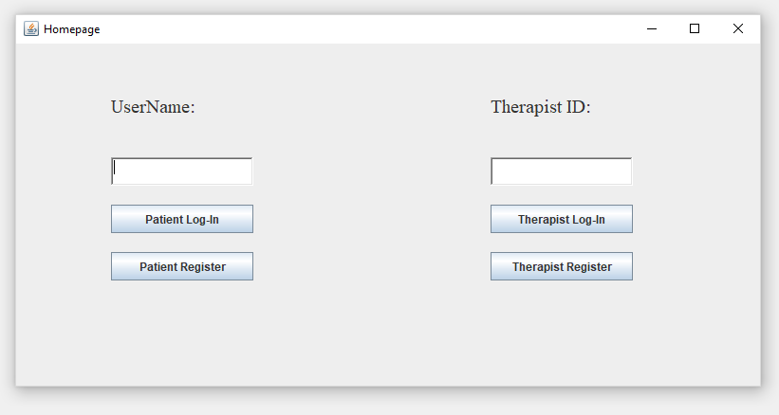

1.The Final System/ Homepage

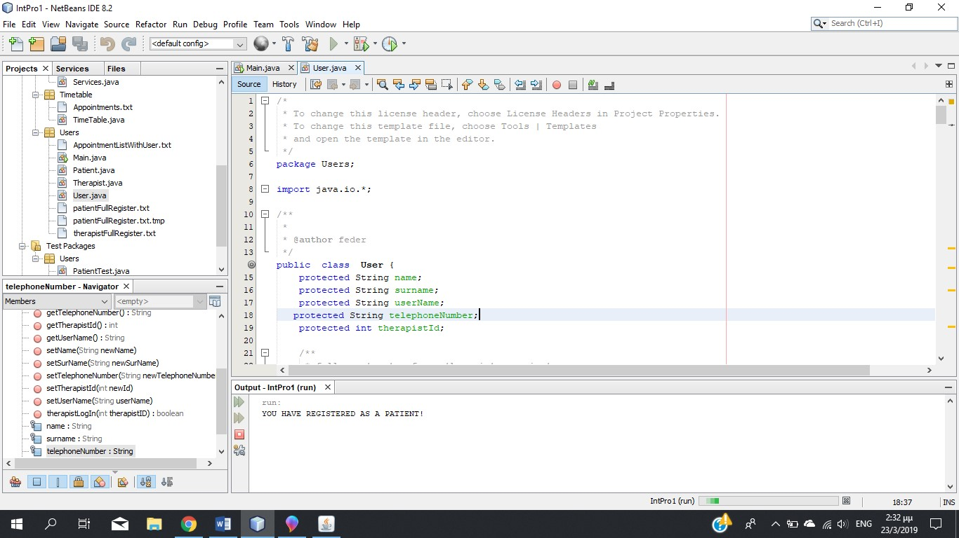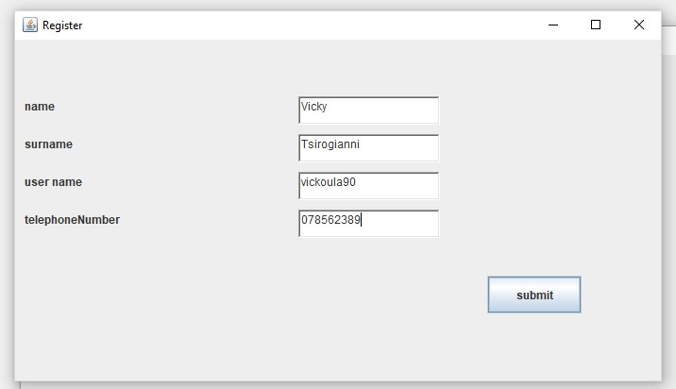

2.The Final System/ Register-Patient

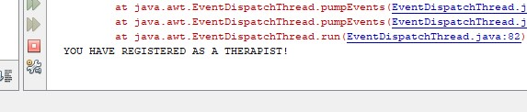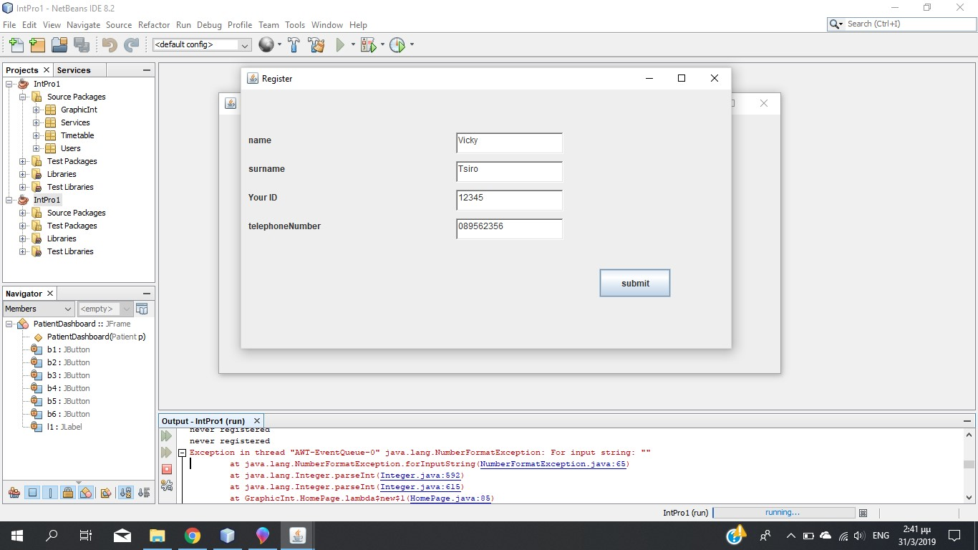

3.The Final System/Register-Therapist

The patient will be able to book an appointment, view available services, update personal details and cancel the account.

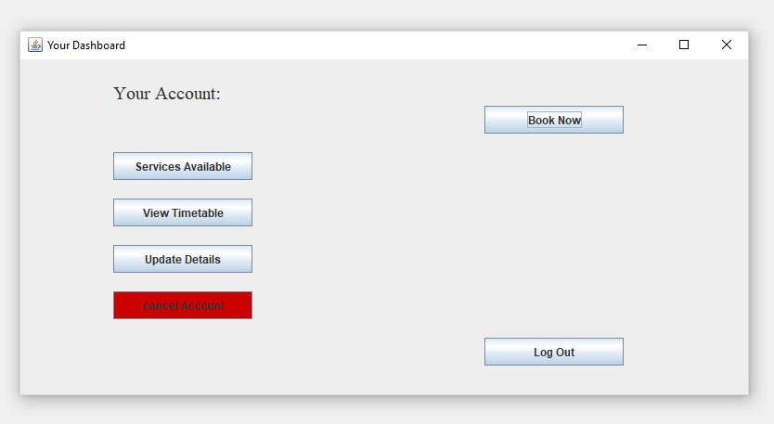

4.The Final System /Your Dashboard=Patient

The patient can book an appointment by entering in the specific service, with the date they desire and the length of the service, which will be stored in a text file.

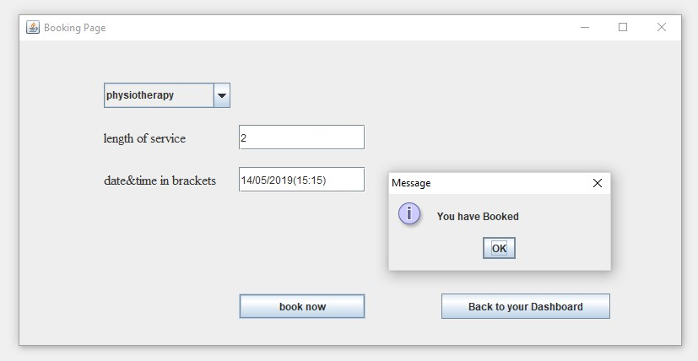

5.The Final System/Booking Page

Another feature available for the patients is to view their timetable which will simply display their appointments, with date, time and therapist’s name.

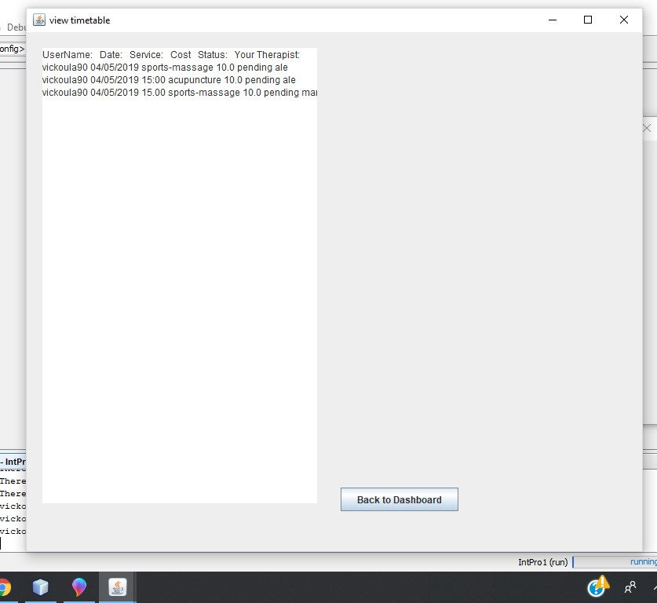

6.The Final System /View Timetable-Patient

If the patient wants more details about a service, he can choose it from a text box, and a pop up a window will display them.

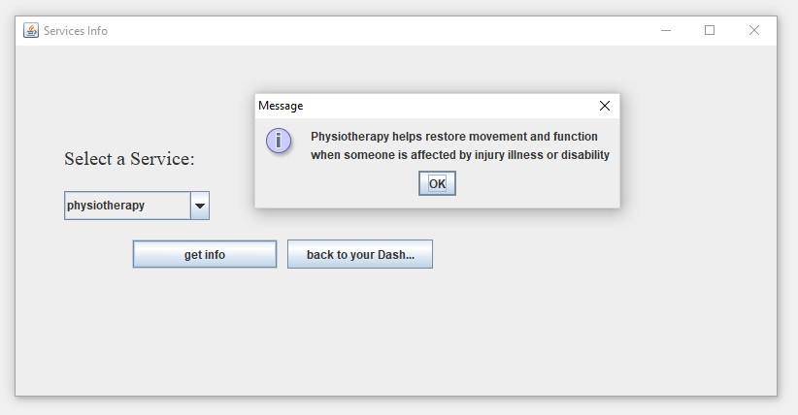

7.The Final System /Service Info

If the patient needs to update personal details such as, a phone number, he can easily enter the new number, which will overwrite the existing one. This also applies to the name and surname, if they require to have it changed (except username).

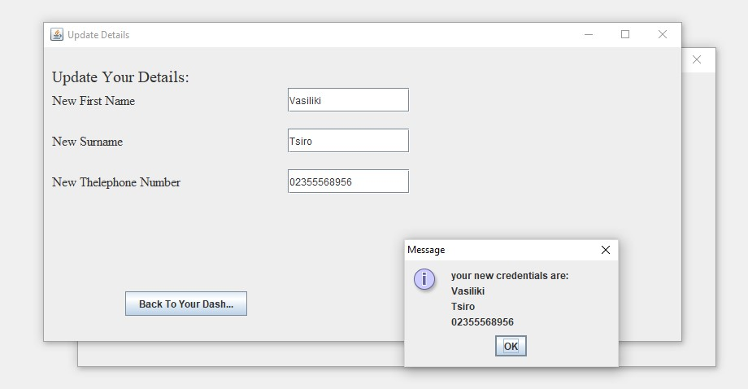

8.The Final System/Update Details

The therapists can similarly view their timetable and update patient’s status.

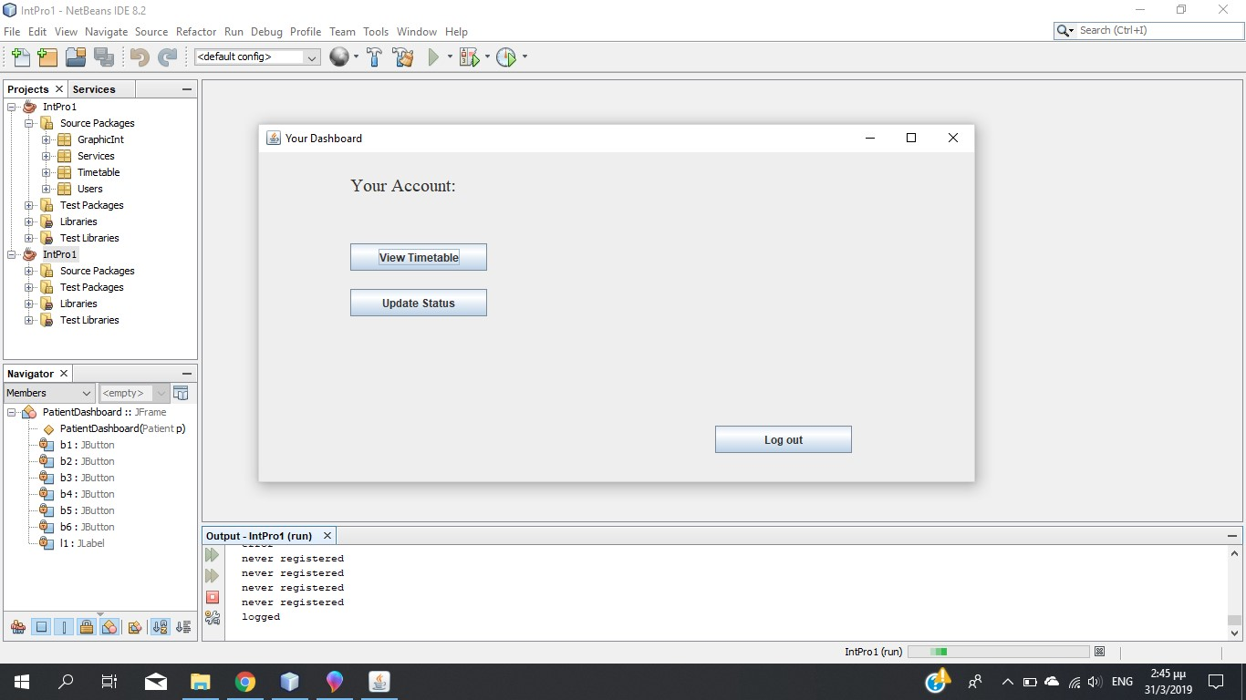

9.The Final System/Your Dashboard-Therapist

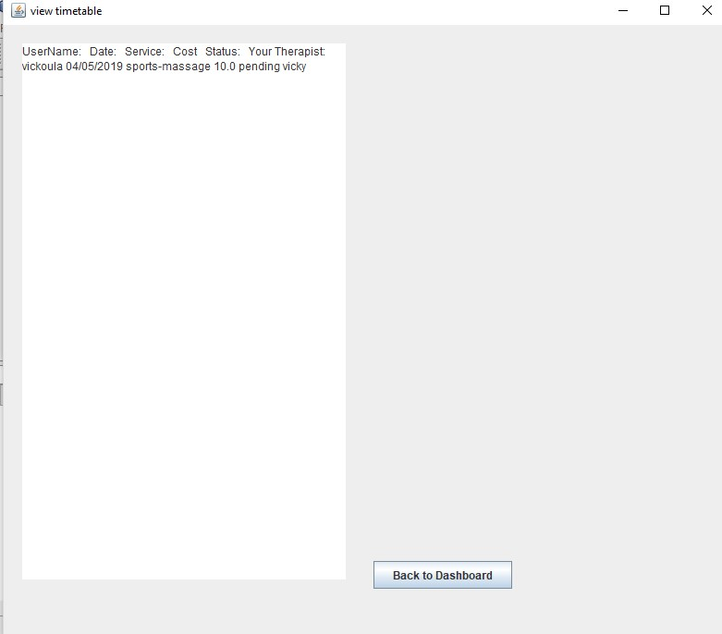

10.The Final System/View Timetable-Therapist

If the therapist wants to change the status of the treatment, he will need to enter patient’s details and set the status to complete, in progress, pending or not completed. By setting the status to not completed, it will either be the result of the patient or the therapist cancelling the treatment.

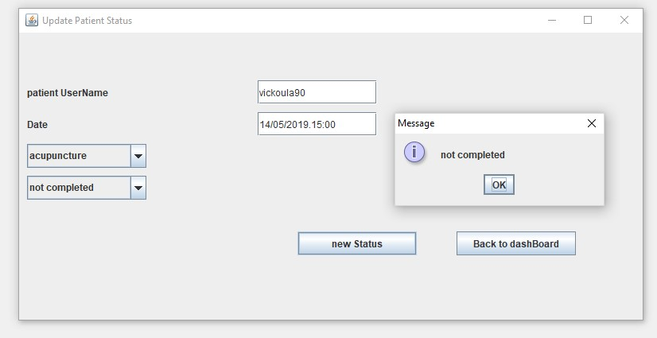

11.The Final System/Update Patient’s Status

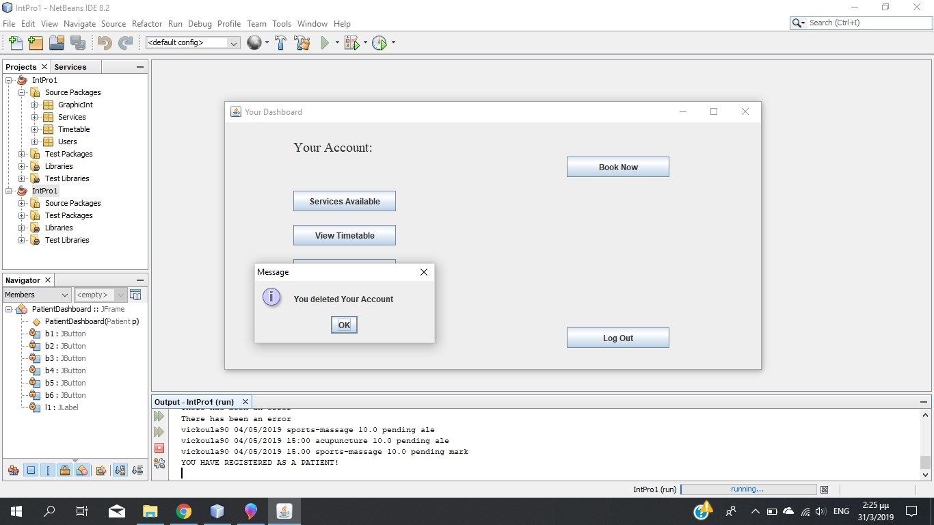

12.The Final System/Delete Account

**Test plans**

|  |  |  |  |
| --- | --- | --- | --- |
| **Method** | **Expected Result** | **Actual Result** | **Screen Captures** |
| **Register as a**  **Patient** | You have  Registered as a Patient | **Passed** |  |
| **Register as a**  **Patient**  **(put some information)** | Enter  valid values | **Passed** |  |
| **Register as a**  **Patient**  **(no information)** | Enter  valid values | **Passed** |  |
| **Register as a Therapist** | You have  Registered as a Therapist | **Passed** |  |
| **Register as a Therapist**  **(put some information)** | Enter  valid values | **Passed** |  |
| **Register as a Therapist**  **(no information)** | Enter  valid values | **Passed** |  |
| **Log in as a**  **Patient** | Logged | **Passed** |  |
| **Log in as a**  **Patient**  **(wrong information)** | Patient never registered | **Passed** |  |
|  |  |  |  |
| **Log in as a**  **Therapist** | Logged | **Passed** |  |
| **Log in as a**  **Therapist**  **(wrong information)** | Therapist never registered | **Passed** |  |
| **Update**  **Details** | Your new credentials are | **Passed** |  |
| **Update**  **Details (put some information)** | Enter  valid values | **Passed** |  |
| **Update**  **Details**  **(no information)** | Enter  valid values | **Passed** |  |
| **Update**  **Status** | ok | **Passed** |  |
| **Update**  **Status**  **(no information)** | Enter  valid values | **Passed** |  |
| **Display**  **Services** | Select a service | **Passed** |  |
| **Book an**  **Appointment** | You have booked | **Passed** |  |
| **Book an**  **Passed**  **Appointment**  **(put only the length)** | Enter  valid values |  |  |
| **Book an**  **Appointment**  **(put only the date)** | Enter  valid values | **Passed** |  |
| **Book an**  **Appointment**  **(no service selection)** | Enter  valid values | **Passed** |  |
| **Display**  **Timetable**  **(Patient)** | It will display all the appointments | **Passed** |  |
| **Display**  **Timetable**  **(Therapist)** | It will display all the appointments | **Passed** |  |
| **Delete Account** | You deleted your account | **Passed** |  |

**Evaluation of the system**

By referring closely to the project’s specifications, our proposed system effectively meets these needs. The users can successfully create an account, book an appointment or control their personal information and timetable. However, there are some features that could be improved to make the system even better overall for the client and the end user.

For example, the ability for the user to choose the therapist for every appointment. This could be implemented by a separate method, on which the user selects from a list of therapists. This may allow the patient to feel more in control, and therefore more likely to repeat custom.

Another feature that could be implemented to ensure a more efficient, pleasant experience is an online payment. Currently the system relies on payments upon arrival, which may cause problems with people forget about it and then being forced to cancel or delay appointments. This could be implemented by entering credit card details, while ensuring that proper security measures are taken to secure the process.

The system could also use a password and a confirmation email that will provide extra security to the user’s information. This would help reassure both the client and the end user about the legitimacy of the email address provided, and another form of conformation if necessary upon arrival.

There are also some issues that came when the system was being developed, that could be fixed if the team had more time. The system could check if the user’s username or password already exists. If it was, it could message the user to enter a new one. Also, it would be better if the system could check for available appointments and inform the user if the service for that time and date is already taken.

Now, all the therapists can change the status of a patient’s appointment. It would be better if only the therapist who is in charge for this patient, could change the status, providing all the necessary notes for the patient’s progress.

There are many features that can be implemented to the proposed system, but the cost and the complexity will increase, so it is better in the beginning, until the users are familiar with its functionality to proceed with the simpler version.

**Group meeting Notes**

**Group Name/Date/Place/Time:** Wednesday 30th January

**Persons Attending:** Jack Weir, Darren Smith, Federico Vivaldo, Vicky Tsirogianni

**Persons Absent:** No

**Purpose of Meeting:** Meet the group

**Discussion: -**

**What have you done since the last meeting?**

-

**What do you plan to do before the next meeting?**

Introduced ourselves to each other and discussed the project. Assigned tasks to each other to have completed for next week.

**Is there any impediment in your way?**

No lectures regarding business case yet so we’re having a rough attempt which we will refine later.

**Action/Next Steps:**

|  |  |  |  |
| --- | --- | --- | --- |
| **Who** | **What** | **When** | **Comments:** |
| Jack Weir | Business case/Use case | 5th Feb | Rough draft |
| Federico Vivaldo | Business case/Use case | 5th Feb | Rough draft |
| Vicky Tsirogianni | Business case/Use case | 5th Feb | Rough draft |
| Darren Smith | Business case/Use case | 5th Feb | Rough draft |

**Next Meeting Date/Time/Location:** Tuesday, 5th February, 10:00, M139/141

**Group Name/Date/Place/Time:** Tuesday 5th February, 10:00 M139/141

**Persons Attending:** Jack Weir, Darren Smith, Federico Vivaldo, Vicky Tsirogianni

**Persons Absent:** No

**Purpose of Meeting:** Review draft of business case and discuss ideas to put forward for next draft of business case.

**Discussion:**

**What have you done since the last meeting?**

Produced a rough draft of business case and use cases.

**What do you plan to do before the next meeting?**

Produce next draft of business case and produce Class Diagrams and Use Case Diagrams.

**Is there any impediment in your way?**

No

**Action/Next Steps:**

|  |  |  |  |
| --- | --- | --- | --- |
| **Who** | **What** | **When** | **Comments:** |
| Jack Weir | Use Case Diagram | 12th Feb |  |
| Federico Vivaldo | Class Diagrams | 12th Feb |  |
| Vicky Tsirogianni | Business Case | 12th Feb | Final draft to be done |
| Darren Smith | Use Case Textual Desc. | 12th Feb |  |

**Next Meeting Date/Time/Location:** Tuesday, 12th February, 10:00, M139/141

**Group Name/Date/Place/Time:** Tuesday 12th February, 10:00 M139/141

**Persons Attending:** Jack Weir, Darren Smith, Federico Vivaldo, Vicky Tsirogianni

**Persons Absent:** No

**Purpose of Meeting:** Begin to code and produce wireframes

**Discussion:**

**What have you done since the last meeting?**

Completed Business Case and Use Cases and agreed upon these with Mark.

**What do you plan to do before the next meeting?**

Have some code of the agreed classes complete.

**Is there any impediment in your way?**

Getting code working together.

**Action/Next Steps:**

|  |  |  |  |
| --- | --- | --- | --- |
| **Who** | **What** | **When** | **Comments:** |
| Jack Weir | Timetable class code | 19th Feb | Struggled due to complexity |
| Federico Vivaldo | User class code | 19th Feb | Patient and Therapist |
| Vicky Tsirogianni | Services class code | 19th Feb |  |
| Darren Smith | Wireframes | 19th Feb | Prototypes |

**Next Meeting Date/Time/Location:** Tuesday, 19th February, 10:00, M139/141

**Group Name/Date/Place/Time:** Tuesday 19th February, 10:00 M139/141

**Persons Attending:** Jack Weir, Federico Vivaldo, Vicky Tsirogianni

**Persons Absent:** Darren Smith

**Purpose of Meeting:** Continue coding and discuss any issues or changes to be made

**Discussion:**

**What have you done since the last meeting?**

Began coding the timetable, user and services classes.

**What do you plan to do before the next meeting?**

Have first increment of system completed.

**Is there any impediment in your way?**

Issues with understanding how the timetable class will function.

**Action/Next Steps:**

|  |  |  |  |
| --- | --- | --- | --- |
| **Who** | **What** | **When** | **Comments:** |
| Jack Weir | Research timetable class | 26th Feb | Work with Vicky |
| Federico Vivaldo | User class code | 26th Feb | Continued from previous week |
| Vicky Tsirogianni | Research timetable class | 26th Feb | Work with Jack |
| Darren Smith | Wireframes | 26th Feb | Continued from previous week |

**Next Meeting Date/Time/Location:** Tuesday, 26th February, 10:00, M139/141

**Group Name/Date/Place/Time:** Tuesday 26th February, 10:00 M139/141

**Persons Attending:** Jack Weir, Federico Vivaldo, Vicky Tsirogianni, Darren Smith

**Persons Absent:** No

**Purpose of Meeting:** Continue coding and discuss how timetable class will work

**Discussion:**

**What have you done since the last meeting?**

Federico continued coding the User class, Jack and Vicky researched how to approach and get the timetable class functioning properly, Darren continued with wireframes.

**What do you plan to do before the next meeting?**

Have timetable class working and first increment ready to test. Have first UI ready.

**Is there any impediment in your way?**

Timetable class is too complex.

**Action/Next Steps:**

|  |  |  |  |
| --- | --- | --- | --- |
| **Who** | **What** | **When** | **Comments:** |
| Jack Weir | Research timetable class | 5th Mar | Work with Vicky |
| Federico Vivaldo | First UI attempt | 5th Mar | Work with Darren |
| Vicky Tsirogianni | Research timetable class | 5th Mar | Work with Jack |
| Darren Smith | Wireframes | 5th Mar | Work with Federico |

**Next Meeting Date/Time/Location:** Tuesday, 5th March, 10:00, M139/141

**Group Name/Date/Place/Time:** Tuesday 5th March, 10:00 M139/141

**Persons Attending:** Jack Weir, Federico Vivaldo, Vicky Tsirogianni, Darren Smith

**Persons Absent:** No

**Purpose of Meeting:** Test increment and continue working on the system UI.

**Discussion:**

**What have you done since the last meeting?**

Decision to remove timetable class as it was too complex has been made.

**What do you plan to do before the next meeting?**

Have second increment tested and produce test tables for testing of final increment.

**Is there any impediment in your way?**

No

**Action/Next Steps:**

|  |  |  |  |
| --- | --- | --- | --- |
| **Who** | **What** | **When** | **Comments:** |
| Jack Weir | Produce test tables | 12th Mar |  |
| Federico Vivaldo | Continue coding | 12th Mar |  |
| Vicky Tsirogianni | Continue coding | 12th Mar |  |
| Darren Smith | Continue working on UI | 12th Mar |  |

**Next Meeting Date/Time/Location:** Tuesday, 12th March, 10:00, M139/141

**Group Name/Date/Place/Time:** Tuesday 12th March, 10:00 M139/141

**Persons Attending:** Federico Vivaldo, Vicky Tsirogianni, Darren Smith

**Persons Absent:** Jack Weir

**Purpose of Meeting:** Continue coding and testing the final increment.

**Discussion:**

**What have you done since the last meeting?**

Test table produced and final increment complete.

**What do you plan to do before the next meeting?**

Complete code and complete UI.

**Is there any impediment in your way?**

Some bugs in the system.

**Action/Next Steps:**

|  |  |  |  |
| --- | --- | --- | --- |
| **Who** | **What** | **When** | **Comments:** |
| Jack Weir | Continue coding/UI | 19th Mar |  |
| Federico Vivaldo | Continue coding/UI | 19th Mar |  |
| Vicky Tsirogianni | Continue coding/UI | 19th Mar |  |
| Darren Smith | Continue coding/UI | 19th Mar |  |

**Next Meeting Date/Time/Location:** Tuesday, 19th March, 10:00, M139/141

**Group Name/Date/Place/Time:** Tuesday 19th March, 10:00 M139/141

**Persons Attending:** Jack Weir, Federico Vivaldo, Vicky Tsirogianni, Darren Smith

**Persons Absent:** No

**Purpose of Meeting:** Test final increment and discuss plans for presentation and any changes to project documentation.

**Discussion:**

**What have you done since the last meeting?**

Final increment complete.

**What do you plan to do before the next meeting?**

Make any necessary changes to Use Case diagrams, textual descriptions etc.

Begin working on the presentation.

**Is there any impediment in your way?**

Some bugs in the system.

**Action/Next Steps:**

|  |  |  |  |
| --- | --- | --- | --- |
| **Who** | **What** | **When** | **Comments:** |
| Jack Weir | Use Cases | 26th Mar |  |
| Federico Vivaldo | Class Diagrams | 26th Mar |  |
| Vicky Tsirogianni | Add all documentation together for final project | 26th Mar |  |
| Darren Smith | Presentation PP | 26th Mar |  |

**Next Meeting Date/Time/Location:** Tuesday, 26th March, 10:00, M139/141

**References**

* “Find a line in a file and remove it”, (n.d.) Retrieved from:

<https://stackoverflow.com/questions/1377279/find-a-line-in-a-file-and-remove-it?fbclid=IwAR0Sbb_2rahNtNv4FvsTagMC5uBKCUo8o4OBJKBnzM6fDPqGuaL1nPrD-JQ>